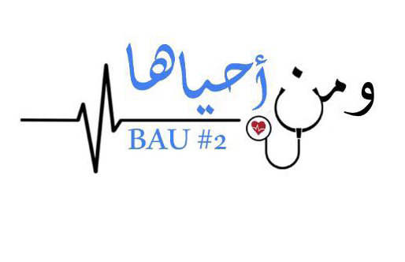
GI Final
1) One of these does not induce gastrin secretion?
Motilin
Secriting
Glucagon
Vip
2) Caputa medusa related to ?
Portal hypertension
3) Caputa medusa related to ?
Portal hypertension
4) Intoxoication by bacillus .....in?
Fried rice and pasta
5) FAP associated with what gene mutation?
APC
DNA mismatch genes
6) the drug used to treat traveler's diarrhea?
bismuth ...
7) the drug that has opioid action?
loperamide
8) Most of lipid digestion occurs in which of the following organ:
Small I
Large
Duodenum*
mouth
9) Curling ulcer >>burn related
10) Visceral leishmania treatment
11) How much is the fiber intake for male and female?
12) Giardia treatment of the pregnant women
13) a patient with caput medusae the case is?
portal hypertension
14) a patient with spots on oral and buccal he have a?
peutz-jeghers syndrome
15) Which is the following portosystemic anastomosis is false :
Jejunoileum
16) The congenital abnormality pancreatic divisum result from?
17) Bile contains all of the following except?
Cholesteol
Lecithin
Lysolecothin*
Bile salt
bilrubin
18) The artery that supply lower esophagus and lesser curvature of the stomach?
Left gastric artery
19) which of the following is the least cuz of fulminate liver disease : HB //HC // autoimmune //HA
20) A new born had jaundice after 10 hours of his birth and had no obstruction what is the cause ?
sepsis
21) Which of the following isn’t non-starch polysaccharides fiber
lignins
Lycra
22) which one of the following worms doesn't infect the lung?
enterobus vermicularise
23) - gene mutation in fap?
Apc
Dna mismatch
24) delay gastric emptying?
Cck
25) doesnt cause pneumonia?
Hookworm
Entrobuis vimoc..
26) pruritis in entrobuis?
Femal migrate to perianal region and lay her egges
27) hemochromatosis ?
Hfe
28) A patient 11 years old has hamartomatous polyp and hyperpigmentation?
Peutz jeghers syndrome

