و من أحياها- UGS Final
ملاحظة: هذه الأسئلة تم تجميعها من بوست و من أحياها من قبل طلاب من اوفردوز فاحتمال وجود الخطأ وارد.
- Factors that facilitate the transmission of STI/RTI except?
> sterile procedures
- Which of the following cross each other?
> ureter & uterine aa
- Which of the following is correct about a mature teratoma?
> benign even in adults
- Which of the following is true regarding extramammary paget disease?
> histologically undifferentiated from melanoma
- Which of the following is a sign seen in endemic schistosomiasis?
> haematuria
- Progesterone & oestrogen have the same effect in?
- The most important hormone for initiation of puberty?
- In which of the following crescentic GN is pauci-immune?
- Which of the following is incorrect regarding a UTI?
> F:M ratio is 3:1
- The outer layer of seminiferous tubules is formed by?
> myoid cells
- Embryological origin of seminal vesicles?
- Embryological origin of the uterine ligament?
> gubernaculum
- Serous carcinoma is related to?
> p53 mutations
- Non-proliferative cystic change is associated with?
> duct dilatation
- trichomonas vaginalis in a male, the best specimen for testing is?
> urethral swab culture (most likely the answer)
> urine sample culture
> blood
- radiosensitive seminoma
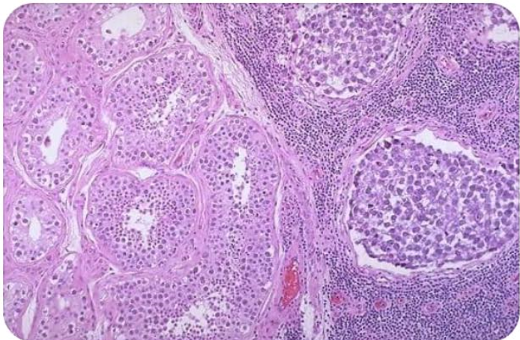
- efferent ducts develop from?
> mesonephric tubules
- Which of the following is correct regarding breast cancer treatment?
- Lymphatic drainage of the upper 2/3 of the vagina?
> internal iliac LNs
- Bound to the sinus of epididymis?
- Doesn’t culture in artificial media?
- Most preferred trichomonas vaginalis screening method? Should it be screened in an asymptomatic male?
- Part of the broad ligament directed posteriorly?
- Is reduced during fasting?
- The most important prognostic factor with metastasis?
> LN involvement
- Which of the following changes carries a higher risk for invasive breast cancer?
> sclerosing adenosis
- Best candida albicans laboratory test?
- Tanner staging is based on?
- Onion-skin appearance is seen in?
> malignant HTN
- Not a virulence factor for nisseria?
- E6 role?
- Somatically acquired mutation in the tumour suppresser gene?
> identified in more than 20% of CC
- Peripheral zone drains into?
> prostatic sinus
- Which of the following is true regarding bladder cancer?
- Which of the following drugs induce interstitial nephritis?
- Which of the following is more associated with endometrial carcinoma type 1?
- Progestin analogue effect?
- Causes hyperchloremic metabolic acidosis?
> renal tubular acidosis type II
- Lowest length of epithelium is found in?
- Embryological origin of seminal vesicles?
- Breast cancer like seminoma in testes?
- Loss of urine concentration mechanism is due to?
> decreased interstitium osmolarity
- Which of the following decreases in fasting?
- The osmolarity of the descending tubule increases while in the ascending tubule decreases due to?
> the descending filtrates water and the ascending filtrates ions
- Which of the following bacteria can’t be cultured?
- Small umbilicated papule is caused by?
> molluscum contacgiosum
- Finasteride MOA?
> inhibits alpha dihydrotesterone
- Cells that produce testosterone in females are called?
> ovarian hilar cells
- Anabolic steroids effect in an 18 year old boy?
- Locally invasive but doesn’t metastasise?
> verrucous carcinoma
- True about Bowenoid papulosis?
> reddish brown lesions
- True about prostate carcinoma?
> osteoblastic more than osteolytic
- Somatic mutation in prostate cancer involve?
> TMPRSS2-ETS
- True about gestational carcinoma?
- True about trophoblastic disease?

