Endocrine
Reset Exam Practical

- This is a histological section in pituitary gland
- Name the identified part of pituitary gland
- Identify the pointed histological structure
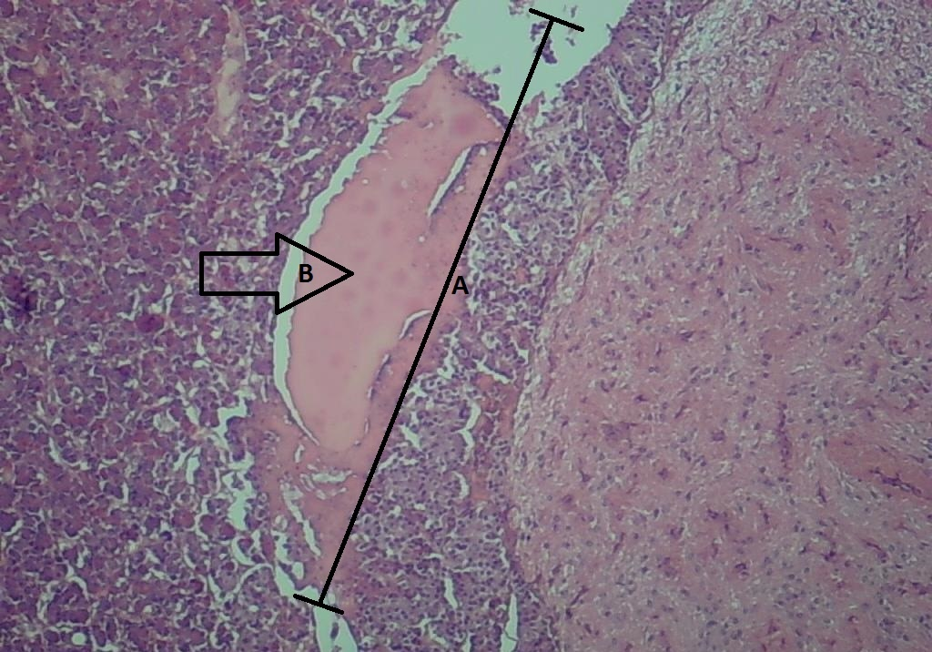

2. a): Name this gland
b): Identify the pointed zone

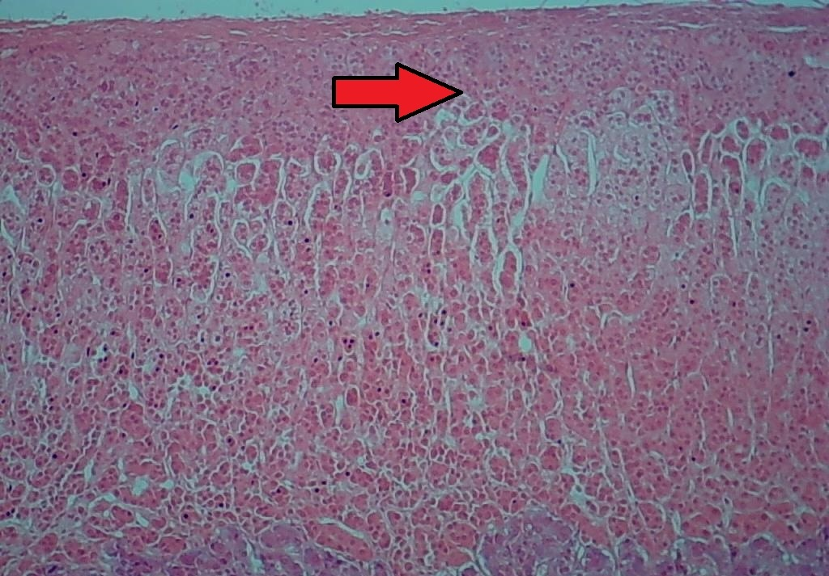

- This is a histological section in pancreas; name the secretion of the pointed cells (Purple colored cells)

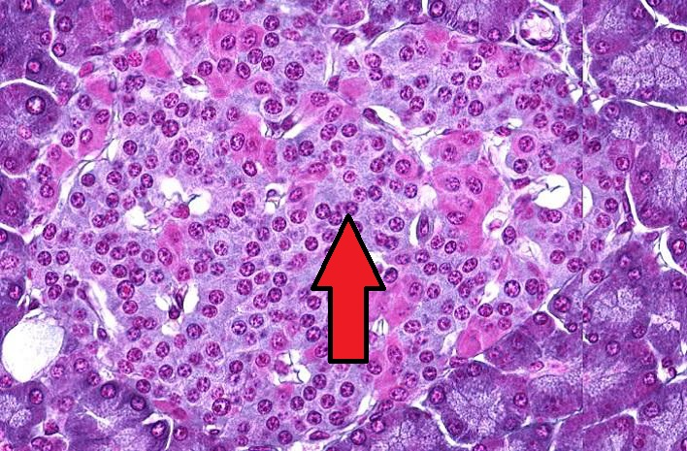

- Which of the following cell types secretes parathyroid hormone?
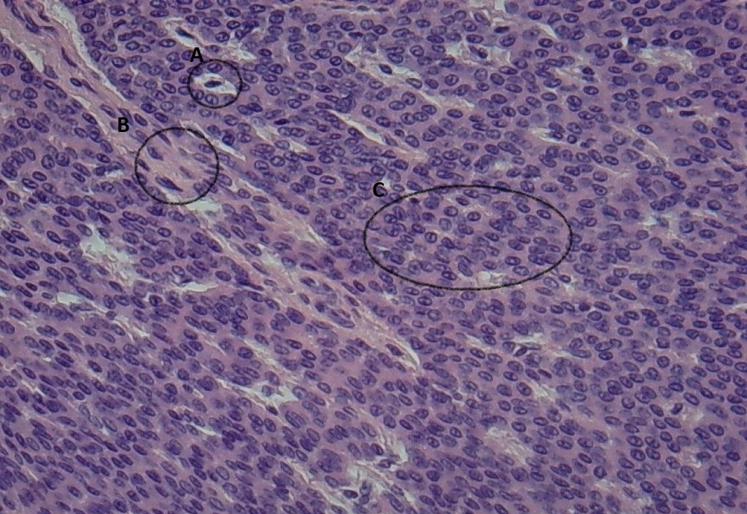

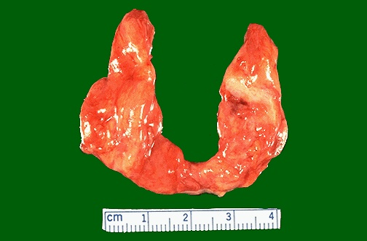
5. This is a case of:
A. Multinodular goiter
B. Atrophy due to Hashimoto thyroiditis
C. Hurthle cell carcinoma
D. Graves disease
E. Toxic adenoma

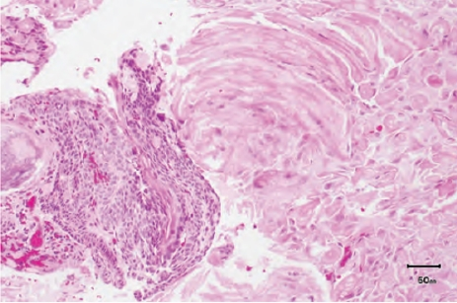
6. Which of the following statements regarding this tumor is true?
A. It does not cause visual disturbances
B. This tumor is mostly malignant
C. Papillary type occurs more in children
D. This is an example of papillary type
E. This is an example of adamantinomatous type

7. Which of the following is the most likely diagnosis?
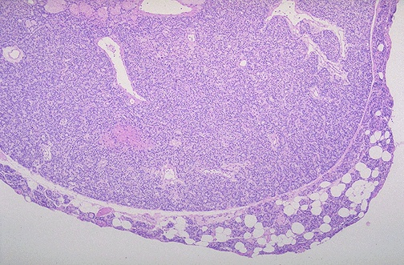
A. Papillary thyroid carcinoma
B. Medullary thyroid carcinoma
C. Hurthle cell carcinoma
D. Parathyroid adenoma
E. Parathyroid carcinoma

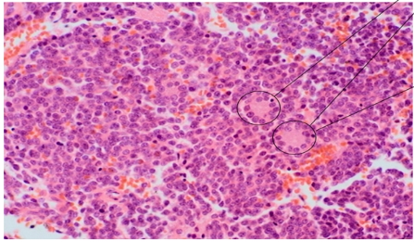
8. This adrenal tumor is:
A. pheochromocytoma
B. Neuroblastoma
C. Ganglioneuroma
D. Myelolipoma
E. Fibrosarcoma

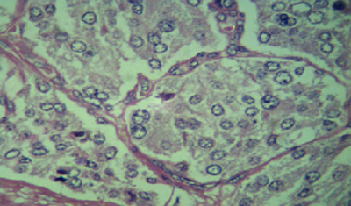
9. Name the nests present in this tumor
A. Pseudorosettes
B. Walthard nests
C. Brunn’s nests
D. Retention nests
E. Zellballen nests

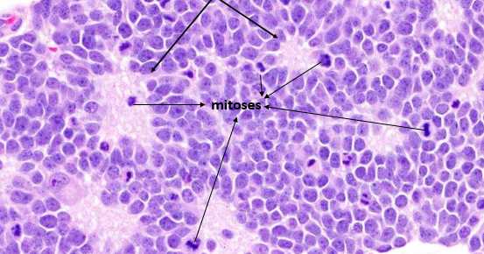
10. The rosettes in this tumor are called:
A. Papillary rosettes
B. Flexner rosettes
C. Inclusion rosettes
D. Homer Wright rosettes
E. Pseudorosettes

11. An obese individual with type 2 diabetes usually shows:

a. A sudden onset of symptoms.
b. A lower plasma level of insulin than a normal individual.
c. Significant improvement in glucose tolerance if body weight is
reduced to normal.
c. Benefits from receiving insulin about 6 hours after a meal.
d. Lower plasma levels of glucagon than a normal individual.

12. Which one of the following is elevated in plasma during the absorptive (fed) period as compared with the post absorptive (fasted) state?

a. Glucagon.
b. Acetoacetate.
c. Chylomicrons.
d. Free fatty acids.
e. Lactate.

13. A 26 year old female patient came with thyrotoxicosis. Free T4 was high and TSH was low. Thyroid uptake was low. Which test do you prefer to do?
a. Pituitary MRI
b. Thyroglobulin
c. Thyroid ultrasound
d. Thyroid scan
e. Total T4

14. Thyroglobulin is increased and thyroid uptake is low in which of the following?
a. Exogenous thyrotoxicosis
b. Thyroiditis
c. Toxic multinodular goiter
d. Graves disease
e. Toxic adenoma

15. Which of the following is a cause of thyrotoxicosis with low uptake?
a. Plummer disease
b. Exogenous thyrotoxicosis
c. Toxic multinodular goiter
d. Graves disease
e. Toxic adenoma

